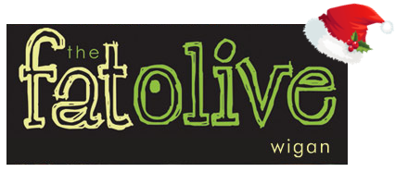

**Boxing Day 2021**

**3 courses - £25.95**

**Starters**

Leek and Potato Soup with fresh Bread (V)

Smooth Chicken Liver Pâté, Cranberry Chutney and Toasted crostini

Grilled Black Pudding, Braised chorizo and Leeks, Pea puree and a Red Wine Jus

Smoked Salmon and Atlantic prawns, roasted Fennel and Pea Shoot Salad, Lime and Coriander dressing

Tomato, Basil and Mozzarella Bruschetta, Rocket and Red Pepper salad and a Balsamic Glaze (V)

**Main Courses**

8oz Sirloin Steak, Garlic Mushrooms, Hand Cut Chips and Peppercorn Sauce

Herb Crusted Cod Fillet, Fondant Potato, Pea Puree and Chive Butter Crème

Slow braised Lamb Shank, Spring Onion Mash and Rosemary jus

Chicken Supreme Stuffed with Black Pudding, Parmentier Potatoes and Tarragon Sauce

Tiân of Chargrilled Mediterranean Vegetables and Fresh Mozzarella, Lemon and Basil Couscous, Creamed Napoli Sauce

**Desserts**

Vanilla Cheesecake, Fruit Coulis

Sticky Toffee Pudding, Vanilla Ice Cream

Warm Chocolate Brownie, Pistachio Ice Cream

Fat Olive Cheese Plate, Crackers, House Chutney