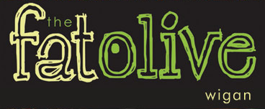

CABARET ARTISTS

FRIDAY 30th NOVEMBER - PJ STOKES
Outstanding male soul vocal entertainer

SATURDAY 1st DECEMBER - PJ STOKES
Outstanding male soul vocal entertainer

FRIDAY 7th DECEMBER - LOGAN STRYX
Fantastic male entertainer

SATURDAY 8th DECEMBER - LOGAN STRYX
Fantastic male entertainer

FRIDAY 14th DECEMBER - LOGAN STRYX
Fantastic male entertainer

SATURDAY 15th DECEMBER - LOGAN STRYX
Fantastic male entertainer

FRIDAY 21st DECEMBER - JOHNNY SAX
Brilliant saxophone and vocalist

