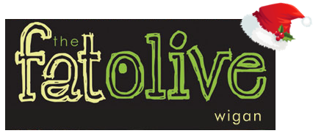

Christmas Cabaret Nights: November - December
(Fridays and Saturdays) 3 COURSE MEAL - £34.95

Fri.26.11.21 JULIE GOLD
Dynamic Female Vocalist

Sat.27.11.21 LOGAN STRYX
Fantastic Young Male Entertainer

FRI.03.12.21 LOGAN STRYX
Fantastic Young Male Entertainer

Sat.04.12.21 LOGAN STRYX
Fantastic Young Male Entertainer

Fri.10.12.21 JAY IRVING
Brilliant Male Vocalist

Sat.11.12.21 JAY IRVING
Brilliant Male Vocalist

Fri.17.12.21 JULIE GOLD
Dynamic Female Vocalist

SAT.18.12.21 DJ MIKE
Fantastic Disco Roadshow

FRIDAY.31.12.21
NEW YEAR’S EVE - £54.95
3 COURSE MEAL
GLASS OF BUBBLY ON ARRIVAL
DJ SEAN PERKINS
SUPERB DISCO

