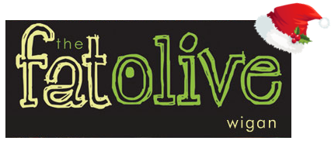

Christmas Eve 2021
3 courses - £24.95

The management and Staff of the Fat Olive wish our Guests a Merry Christmas and a Happy New Year.
Please note that a 10% discretionary service charge will be added to your bill.

Starters
Cream of Roasted Parsnip Soup with Fresh Bread (V)

Chicken Liver Pâté, Cranberry and Caramelised Onion Chutney and Toasted Crostini

Grilled Black Pudding, Crushed Potatoes, Carrot Puree, Pancetta Jus, Parsnip Crisps

Prawn Cocktail, Gem Lettuce, Cucumber, Garlic Croutons and a Marie Rose Sauce

Baked Goats Cheese and Red Onion Tart, Tomato and Basil Salad, Fennel and Cumin Dressing (V)

Main Courses
Roast Turkey with Sage and Onion Stuffing, Rosemary Roast Potatoes, Bacon Wrapped Chipolatas and Thyme Jus

Slow Cooked Brisket of Beef, Garlic Mash or Hand Cut Chips and Red Wine Jus

10oz Rump Steak (£3.00 Supp), Hand Cut Chips, Pepper Sauce, Flat Cap Mushroom and Roasted Tomato

Pan fried Fillet of Cod, Spring Onion, Crushed Potatoes, Pea and Mint Puree, Tomato and Caper Sauce

Braised Lamb Shank (£3.00 Supplement), Garlic mash and Rosemary Jus
Mediterranean Vegetable Risotto, Confit Tomato, Rocket and Balsamic Glaze (V)

Desserts
Warm Christmas Pudding with Brandy Sauce

Sticky Toffee Pudding, Caramel Sauce and Vanilla Ice Cream

Warm Chocolate Brownie with Pistachio Ice Cream

Fat Olive Cheese Board, Grapes, Apple and House Chutney

Vanilla Cheesecake with Fruit Coulis

