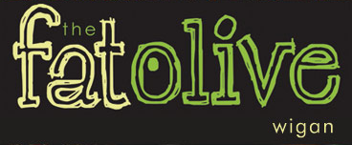
CHRISTMAS EVE MENU 3 COURSES £ 24.95
Starters
Roasted Red Pepper and Tomato soup (v)
Basil pesto drizzle, Fresh bread

Chicken Liver Pâté
Cranberry and caramelised onion Chutney, Toasted crostini

Grilled Black pudding
Celeriac mash, carrot puree, pepper sauce

Pan Fried Rainbow Trout
Confit tomato, cucumber, watercress, lime and coriander dressing

Baked goat’s Cheese Tart (v)
Tomato and basil herb crumb

Main courses
Roast Turkey with sage and onion stuffing
Rosemary roast potatoes, bacon wrapped chipolatas, thyme jus

Slow braised Beef Brisket
Garlic mash or hand cut chips, Caramelised onion jus

10oz Rump steak hand cut chips and Peppercorn Sauce (£3.60 Supp)

Pan-fried Salmon Supreme
Fondant potato, pea and mint puree, red pepper chive crème butter sauce

Slow Braised Lamb Shank
Garlic mash, Rosemary jus

Wild Mushroom and Root Vegetable Risotto (v)
Confit tomato, rocked and balsamic glaze

Desserts
Warm Christmas pudding Brandy sauce

Sticky toffee pudding Caramel sauce, vanilla ice cream
Warm Chocolate brownie, pistachio ice cream
Vanilla and Cream Cheesecake, fruit compote
Fat Olive cheese plate, Crackers, house chutney

