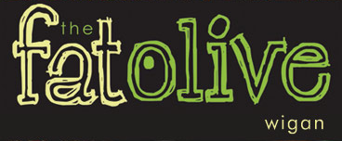
Christmas Evening Menu 2018
3 Courses £22.95 Sunday to Thursday
3 Courses £31.95 Friday and Saturday with Cabaret

Starters

Roasted Red Pepper and Tomato soup (v)
Basil Pesto Drizzle, Fresh bread

Chicken Liver Pâté
Cranberry and caramelized onion Chutney, Toasted crostini

Grilled Black pudding
Celeriac mash, carrot Puree, Pepper Sauce,

Pan Fried Rainbow Trout
Confit tomato, Cucumber, watercress, Lime and Coriander Dressing

Baked Goats cheese tart
Tomato and Basil, herb crumb (v)

Main courses

Roast Turkey with sage and onion stuffing
Rosemary roast potatoes, bacon wrapped chipolatas, thyme jus

Slow braised Beef Brisket
Garlic mash or hand cut chips, Caramelized Onion Jus

Pan-fried Salmon supreme
Fondant potato, pea and mint puree, Tomato and caper Sauce

Slow braised Lamb shank
Garlic mash, Rosemary jus

Wild Mushroom and Root Vegetable Risotto (v)
Confit Tomato, Rocket and Balsamic Glaze

Desserts

Warm Christmas pudding, Brandy sauce

Sticky toffee pudding Caramel sauce, vanilla ice cream
Warm Chocolate brownie, pistachio ice cream
Fat Olive cheese plate, Crackers, house chutney
Vanilla and Cream Cheesecake, Fruit Compote

