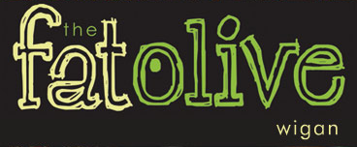
Christmas Evening Menu 2019
3 Courses £23.95 Sunday to Thursday
3 Courses £32.95 Friday and Saturday with Cabaret

Starters
Cream of Broccoli soup (V)
Fresh bread

Chicken Liver Pâté
Cranberry and Caramelized Onion Chutney, Toasted Crostini

Grilled Black pudding
Mash Potato, Carrot Puree, Pancetta Jus and Parsnip Crisps

Pan Fried Mackerel Fillet
Confit Tomato, Cucumber, Watercress, Lime and Coriander Dressing

Baked Goats cheese
Tomato and Basil Salad, Fennel and Cumin Dressing (V)

Main Courses
Roast Turkey with sage and onion stuffing
Rosemary Roast Potatoes, Bacon Wrapped Chipolatas with Thyme Jus

Slow braised Beef Brisket
Garlic Mash or Hand Cut Chips and Red Wine Jus

Pan fried Cod Loin
Spring Onion Crushed Potatoes, Pea and Mint Puree, Tomato and Caper Sauce

Slow Braised Lamb Shank
Garlic Mash, Rosemary Jus

Mediterranean Vegetable Risotto (V)
Confit Tomato, Rocket and Balsamic Glaze

Desserts
Warm Christmas Pudding, Brandy Sauce
Sticky Toffee Pudding, Caramel sauce, Vanilla Ice Cream
Warm Chocolate Brownie, Pistachio Ice Cream
Fat Olive Cheese Plate, Crackers, House Chutney
Lime and Vanilla Cheesecake, Kiwi Fruit Coulis

