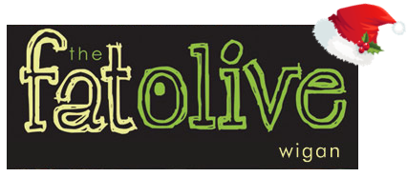

Christmas Evening Menu 2021
£24.95 – Sunday to Thursday (PLEASE NOTE WE ARE CLOSED ON MONDAY’S)
£34.95 – Friday & Saturday with Cabaret

Starters
Cream of Broccoli soup, Fresh Bread (V)

Chicken Liver Pâté, Cranberry and Caramelised Onion Chutney, Toasted Crostini

Grilled Black pudding, Mash Potato, Carrot Puree, Pancetta Jus, Parsnip Crisps

Pan Fried Mackerel Fillet, Confit Tomato, Cucumber, Watercress, Lime and Coriander dressing

Baked Goats Cheese, Tomato and Basil Salad, Fennel and Cumin Dressing (V)

Main Courses
Roast Turkey with Sage and Onion Stuffing, Rosemary Roast Potatoes, Bacon wrapped Chipolatas, Thyme Jus

Slow Braised Beef Brisket, Garlic Mash or Hand Cut Chips, Red Wine Jus

Pan fried Salmon Supreme, Fondant Potato, Pea and Mint Puree, Tomato and Caper Sauce

Slow Braised Lamb Shank, Garlic mash, Rosemary Jus

Roasted Pepper Stuffed with Root Vegetable Risotto, Confit Tomato, Rocket and Balsamic Glaze (v)

Desserts
Warm Christmas Pudding, Brandy Sauce

Sticky Toffee Pudding, Caramel Sauce, Vanilla Ice Cream

Warm Chocolate Brownie, Pistachio Ice Cream

Fat Olive Cheese Plate, Crackers, House Chutney

Vanilla Cheesecake, Kiwi Fruit Coulis

