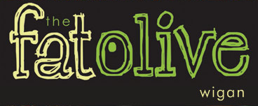
Christmas Lunch Menu 2018
3 courses £15.95
Starters

Creamy Mushroom soup (v)
Fresh bread

Chicken Liver Pâté
Cranberry and Caramelized Onion Chutney, Toasted crostini

Atlantic Prawns Marie Rose
Cucumber and gem lettuce, Herb Croutons and Parmesan

Creamy Garlic Mushrooms and Tarragon (v)
Roasted Garlic Croute, Herb Salad

Main courses

Roast Turkey with sage and onion stuffing
Rosemary roast potatoes, bacon wrapped chipolatas, thyme jus

Chargrilled Pork Loin steak
Garlic Mash or hand cut chips, Pepper Sauce

Pan-fried Hake
Spring onion crushed potatoes, Tomato and Caper Sauce

Wild Mushroom and Root Vegetable Risotto (v)
Confit Tomato, Rocket and Balsamic Glaze

Desserts

Warm Christmas pudding, Brandy sauce

Sticky toffee pudding, Caramel sauce, vanilla ice cream

Warm Chocolate brownie, pistachio ice cream

Mixed berry meringue, vanilla mascarpone

