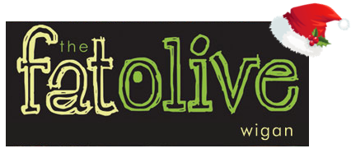
Christmas Lunch Menu 2021
3 courses - £16.95

Starters
Roasted Tomato and Basil Soup, Fresh bread (V)

Chicken Liver Pâté, Cranberry and Caramelised Onion Chutney, Toasted crostini

Atlantic Prawns, Marie Rose Cucumber and Gem Lettuce, Herb Croutons and Parmesan

Creamy Garlic Mushrooms with Tarragon, roasted Garlic Croute and Herb Salad (V)

Main Courses
Roast Turkey with Sage and Onion Stuffing, Rosemary Roast Potatoes, Bacon wrapped Chipolatas and Thyme Jus

Chargrilled Pork Loin Steak, Garlic Mash, or Hand Cut Chips, Pepper Sauce

Pan fried Cod, Spring Onion Crushed Potatoes, Tomato and Caper Sauce

Mediterranean Vegetable Risotto, Confit Tomato, Rocket and Balsamic Glaze (V)

Desserts
Warm Christmas Pudding, Brandy sauce

Sticky Toffee Pudding, Caramel sauce, Vanilla Ice Cream

Warm Chocolate Brownie, Pistachio Ice Cream

Mixed Berry Meringue, Vanilla Mascarpone

